Diocesan statement – our vision for growth and transformation

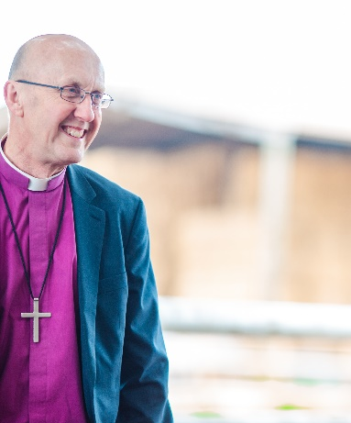
Introduction
We are delighted that you are considering whether this post of [post name] of the [Benefice or Parish name] in the Diocese of Bath and Wells might be right for you. In order to help your prayerful discernment, we want to share a bit about our diocesan vision, within which we hope your own ministry might flourish.
Appointing a priest incumbent is amongst the most significant decisions that any benefice makes. When appointments work out well, they contribute significantly to parishes flourishing and growing in a host of different ways – in spiritual depth, in impact within local communities and in the numbers of people becoming part of the local church. Such flourishing is not, of course, all down to the person appointed as priest. It depends first and foremost upon God. It also depends upon everyone in a benefice being willing and able to contribute their unique gifts, skills, resources and abilities: working alongside their priest and sharing in the ministry of the benefice.
The flourishing and growth of churches always needs attention. It is especially important for us today, as we seek to recover from the effects of the Covid pandemic which accelerated the pattern of decline in church attendance that we have seen across our diocese. Thankfully there are signs that we are recovering from the impact of the pandemic. Not only does national church data showed that our average adult weekly church attendance rose between 2021 and 2022 but, even more encouragingly, we have seen many churches around our diocese develop approaches that respond to the opportunities and challenges in their local context and enable growth to happen.

A vision for growth and transformation
In light of the challenges and opportunities we face, we feel our aim across all our parishes needs to be growing our churches, within and beyond our church buildings, in both numbers and depth of faith, so that we can better work for the transforming of our communities and the life of God’s Kingdom amongst us.

Our shared priorities
To help us pursue this aim, and following consultation across the diocese in 2023, we are inviting all parishes to focus on four particular areas of our ministry together. It is important for clergy considering working in our diocese to know what these priorities are, even though what they look like in practice will vary in each place.
To value and cherish the people and resources we already have | We aim to ensure each person is well supported and equipped as a follower of Jesus Christ and for any ministries they may feel called to undertake, within the local church and wider community. We are committed to supporting the well-being of all our leaders and church officers, both lay and ordained. We have a fully funded clergy well-being service, the offer of peer support groups, and an excellent team of diocesan support staff fully focused on supporting our parishes, chaplaincies and schools.
To develop new Christian worshipping communities | Whether it be new forms of worship in a wide variety of settings and times, church revitalisations or church plants, we long to see the good news of Jesus connect with the people in our communities that our traditional offerings struggle to reach.
To share in ministry and leadership | We are committed to the New Testament vision of the church as a vibrant body of people all using their God-given gifts. We are committed to a model of shared local ministry: raising up and equipping lay and ordained leaders able to share together in leading the church and serving God’s world.
To deepen and grow faith | This is foundational to all we do. We long to see people of all ages and backgrounds, but perhaps especially children, young people and young adults, having more opportunities to discover, explore and grow in faith.

The outcome we are looking for
When he talks about his own ministry in 1 Corinthians, Paul captures the dynamic we are seeking to achieve. “I planted,” he says, “Apollos watered, but God gave the growth”(1 Cor 3: 6). We know that our churches will only flourish and grow as a result of God’s action among us – it is God who gives the growth.
But Paul is also clear that we have a part to play too – in watering and planting, in doing the things that enable the conditions for God’s growth to be supported. So, covered by prayer, our confident hope is that if we are intentional in seeking God’s guidance in planning and supporting growth, then God will honour that to see his people flourish and thrive - in spiritual depth, in impact within local communities, in the numbers of people becoming part of the local church and in transforming communities locally and beyond.

Local shaping and diocesan support
There can’t be any ‘one size fits’ all approach to turning the priorities outlined above into action. They always need to be adapted to local circumstances, opportunities and needs. The task of our diocesan support services is to get behind all that local benefices are doing and apart from their general support, there is specific support for exploring how to grow new Christian communities, how to discern and equip a growing range of ministries in your context and how to work well with children and young people. All these areas of support are grounded in exploring what it means to live out our faith.

What implications does this have for the appointment of clergy?
It is important for us all to appoint clergy to benefices who are ready, willing and able to pray for and share in the vision we have for the flourishing and growth of churches and Christian life in our diocese. We want to create an environment that could be described as high challenge, high support. This means appointing clergy who will not only value all that already exists but will be eager to work with others to build on and develop it. It means appointing clergy who are committed to learning, being creative, and to starting with the gifts God has given to them, their benefice and the wider community. We are therefore looking to appoint candidates who will
- be committed to praying and intentionally seeking the growth and flourishing of the benefices in their care
- relish and expect to work in an environment that is high challenge, high support
- work joyfully and collaboratively with those who share with them locally in ministry and leadership, with their congregations and with others in their locality, to identify ways to grow and develop their churches with the grain of local priorities, resources, skills and passions
- enjoy working in partnership with deanery and diocesan colleagues.

We hope this might be you! We hope that you’d like to join us on the adventure and course we’ve set for our next ten years. We’re praying that God will send us the right labourers for the harvest that God has set before us. Could this be you?
Bishop Michael Archdeacon of Bath

